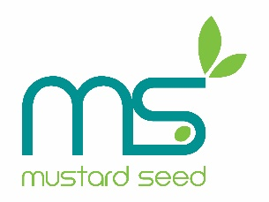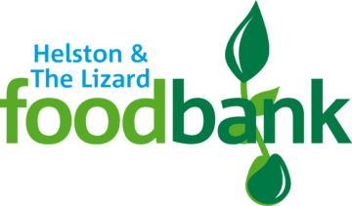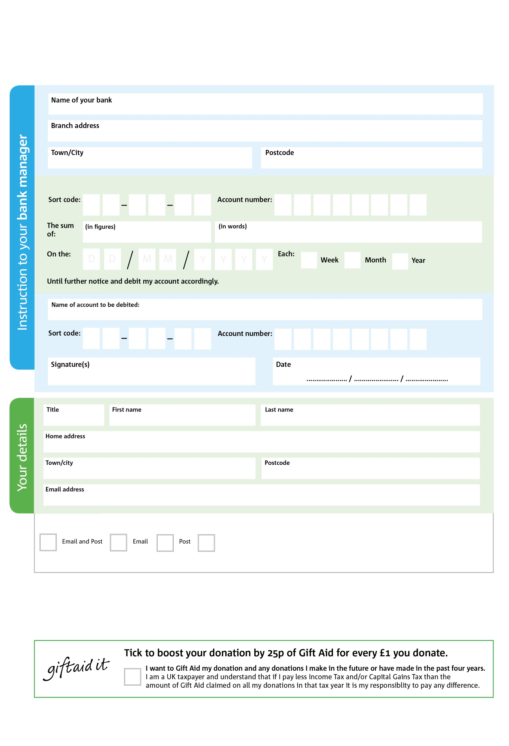

Please post or email this form directly to your bank.

Reg. Charity No: 1127110 | Reg. in England & Wales

**Standing Order Mandate**

**www.helstonthelizard.foodbank.org.uk**

POSTAL ADDRESS: Mustard Seed (SW), Helston and The Lizard, Foodbank 14 – 16 Wendron Street, Helston, Cornwall, TR13 8PS

00

V

11

V

656

V

11

V

111

V

333

V

111

V

00

V

7

5

8

9

0

3

We would love to keep you up to date with information about Helston and The Lizard Foodbank. Please tick your preference:

You can change your preferences any time by contacting us on 01326 564 194 or emailing us: info@helstonthelizard.foodbank.org.uk

I do not wish to receive future communications from Helston and The Lizard Foodbank

Please pay Mustard Seed (SW)

**Data protection**

*‘ Helston and The Lizard Foodbank is committed to protecting your privacy and will process your personal data in accordance with current Data Protection legislation. Helston and The Lizard Foodbank collects information to keep in touch with you and supply you with information relating to our work. To unsubscribe from our newsletter, send a message to the email address above with the word unsubscribe in the subject line. A full data privacy statement for financial donors is available from the foodbank on request.’*

You can change your preferences any time by contacting us on XXXXXXXXXXX or emailing us at XXXX@XXXXXXXXXX.foodbank.org.uk

I do not wish to receive future communications from XXXXXX Foodbank